**Unit 11 digital graphics and animation**

**Creating planets with textures**

My first design idea is planet earth. I will begin by choosing a large texture image of earth. Below is an image of the texture I have chosen.

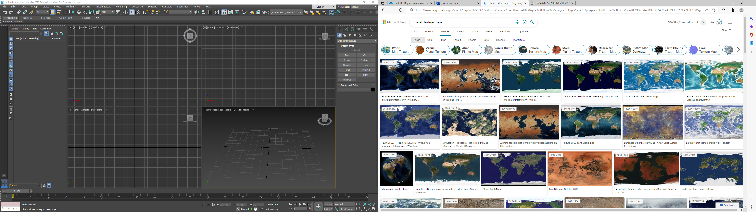

Source([planet texture maps - Bing images](https://www.bing.com/images/search?view=detailV2&ccid=Vk1wwn3x&id=F7B1E02AE2D1850B6D8E7FF4BED180941A45965D&thid=OIP.Vk1wwn3xngsNwxDXs28tAQHaDt&mediaurl=https%3a%2f%2fth.bing.com%2fth%2fid%2fR.564d70c27df19e0b0dc310d7b36f2d01%3frik%3dXZZFGpSA0b70fw%26riu%3dhttp%253a%252f%252feoimages.gsfc.nasa.gov%252fimages%252fimagerecords%252f73000%252f73580%252fworld.topo.bathy.200401.3x5400x2700.jpg%26ehk%3dZN9y1kUKg9JOgktQ0m23CFx7riJdBXW%252bux0nI8bCFts%253d%26risl%3d1%26pid%3dImgRaw%26r%3d0&exph=2700&expw=5400&q=planet++texture+maps&simid=608029630031401786&FORM=IRPRST&ck=AB7BEAA82C5F0C1012E437FD1C358EAA&selectedIndex=0&qft=+filterui%3aimagesize-large&ajaxhist=0&ajaxserp=0)).

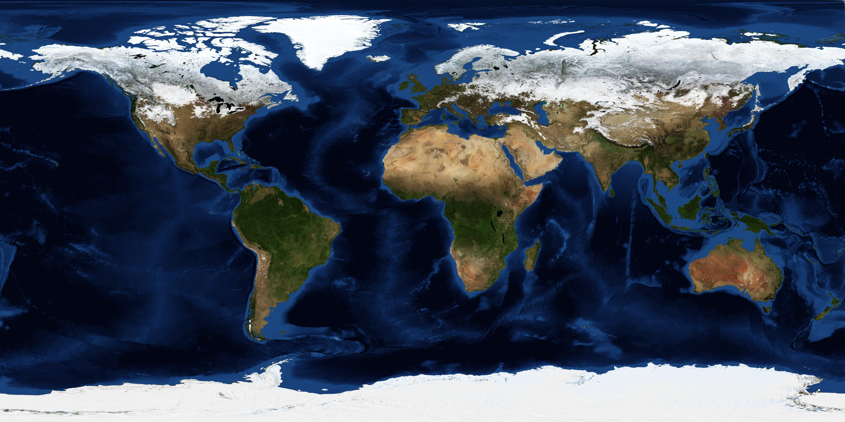

A few reasons why I decided to choose this image compared to others is because:

* The image is large with a big number of pixels 5400 x 2700
* The image is quite detailed
* Image is clear
* Overall good quality
* No watermarks

Due to the fact the image has all the qualities listed above, when I use it to as a material it will lose quality. Hopefully this image won't lose as much because it starts off with very good quality.

I then opened up photoshop which will allow me to make my own edits to this texture. By creating a new layer and multiplying I can then use a soft brush to create designs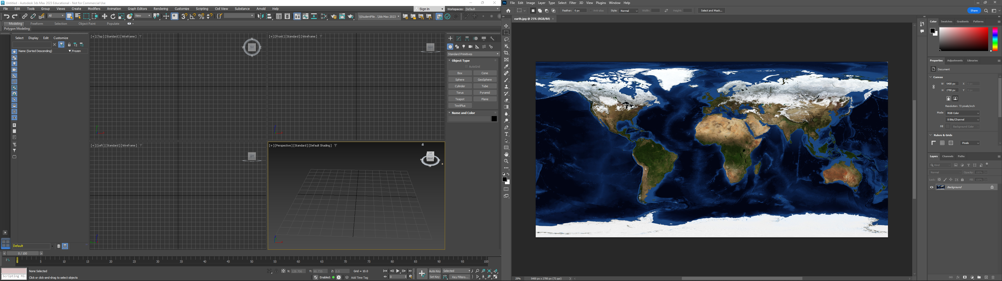

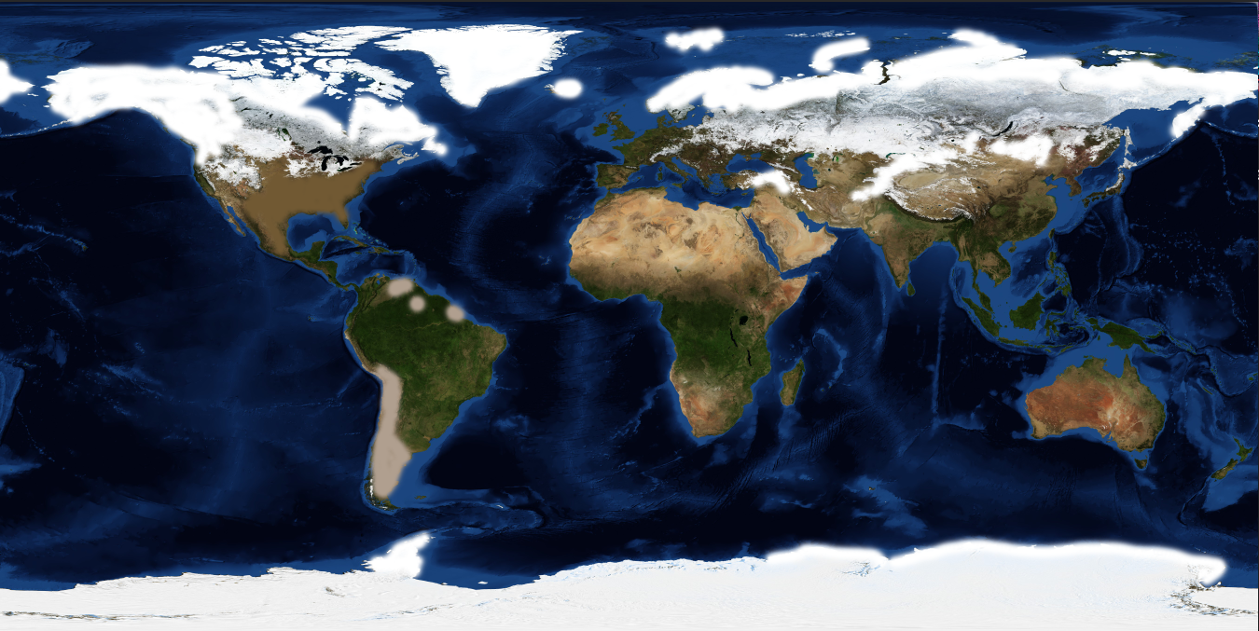

I then went into 3ds studio max and created a simple sphere and set up a free light.

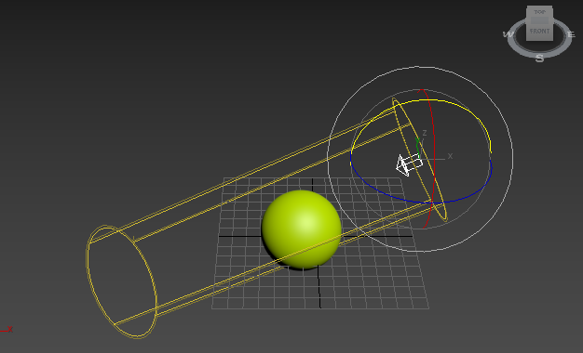

By setting the renderer to scanline rendering, I was able to produce the image shown below.

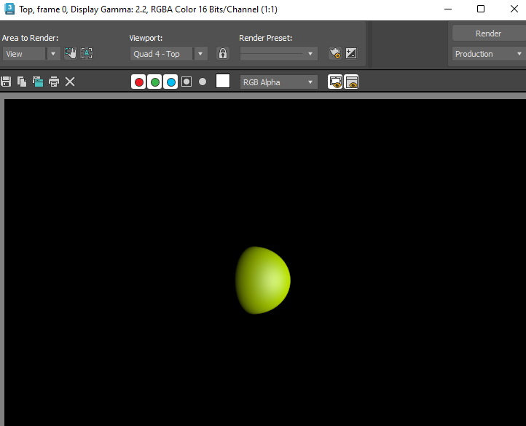

After I had my sphere created, I made a dark background color. Then I clicked on the rendering tab and opened the material editor. I then used these settings.

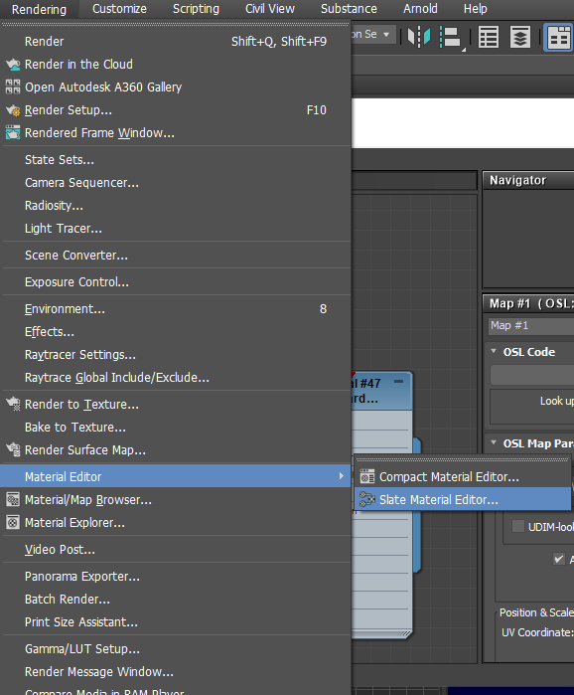

Create a Scanline – Standard material

Set:

* Self-illumination - colour to black
* Specular level 1
* Glossiness 6

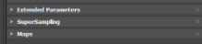After this I went to the maps tab and chose diffuse color then I inserted my bitmap into the bitmap lookup tab.

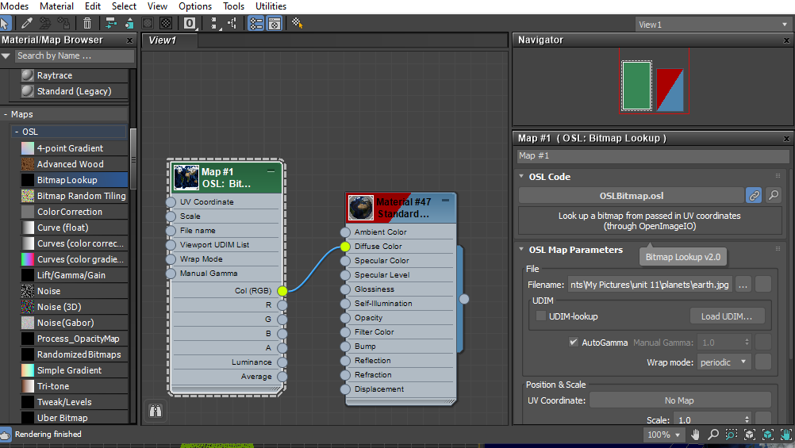

After I selected my image from photoshop, I dragged the color GBB line and attached it to diffuse color. Then I dragged the circle on the right and attached it to my sphere.

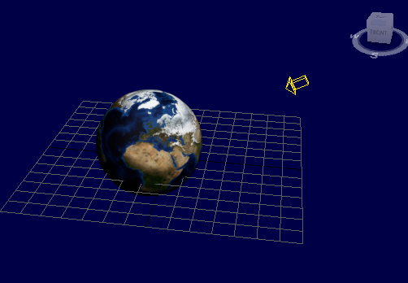

Finally, my project looked like this. I then used the rotating tool to spin my sphere around to get a better angle.

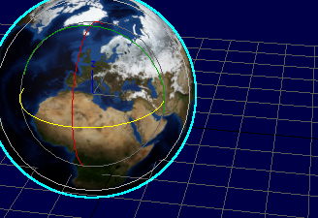

My final design looked like this.

